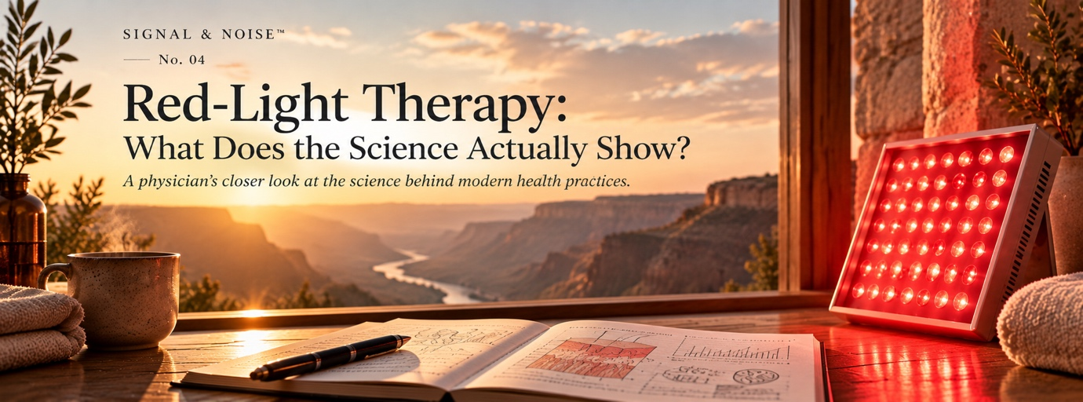
Red-light therapy has made an unusual journey from laboratories and clinical research into gyms, wellness clinics and people’s homes. Masks promise younger-looking skin. Panels are marketed for muscle recovery, inflammation and sleep. Other devices make much more ambitious claims involving testosterone, brain health, mitochondrial function and longevity.
Behind the marketing is a genuine scientific field known as photobiomodulation. Researchers have been studying the effects of low-intensity red and near-infrared light on cells and tissues for decades, and hundreds of randomized clinical trials now exist. The interesting question is therefore not whether red light can affect human biology. It can. The more useful question is how far we can reasonably extend that observation—and which of the increasingly broad health claims are actually supported by human evidence.

The Claim
The basic proposition sounds surprisingly simple: expose the body to particular wavelengths of light and cells may respond in ways that influence energy metabolism, inflammation, circulation and tissue repair. From that foundation has grown an enormous consumer market for LED masks, handheld devices, helmets and full-body panels.
Claims now include improved skin quality and collagen production, faster wound healing, reduced pain and inflammation, improved exercise recovery, increased hair growth, better cognition and sleep, and even effects on hormones and ageing. These claims are often presented together under the single label “red-light therapy,” but scientifically they are very different questions. Evidence that a particular wavelength and dose improves one condition cannot automatically be transferred to another organ, another dose or another device.

Why Might It Work?
Unlike ultraviolet radiation, the red and near-infrared wavelengths generally used in photobiomodulation are not intended to damage tissue or produce substantial heating. Red light commonly occupies roughly the 620–700 nm range, while near-infrared light uses longer wavelengths and penetrates tissue more deeply. Researchers believe these photons can interact with molecules within cells and initiate biological signalling.
One of the leading explanations involves the mitochondria. Cytochrome c oxidase, an enzyme involved in the mitochondrial electron-transport chain, has long been proposed as an important light-sensitive target. Experimental work suggests that light may alter mitochondrial signalling, ATP production, reactive oxygen species and nitric-oxide pathways, producing downstream effects on cellular proliferation, inflammation and repair. There are also proposed mechanisms involving light-sensitive ion channels.
This is biologically interesting, but there is an important qualification. The popular description that red light simply “boosts mitochondrial energy” makes a complicated and still incompletely understood process sound far more settled than it is. Even the role of cytochrome c oxidase remains debated, and some experimental work has questioned whether it fully explains observed effects.
The biological response also appears to depend heavily on dose. More light is not necessarily better. Wavelength, irradiance, total energy delivered, distance from the skin, treatment duration and the tissue being targeted can all influence what happens. That becomes crucial when translating a laboratory protocol into a commercial device.

What Does the Human Evidence Show?
The answer depends heavily on what red-light therapy is being used to treat.
There is reasonably encouraging evidence in dermatology and hair growth. Randomized studies have found improvements in some measures of skin ageing, and one randomized trial involving 137 women reported a reduction in periocular wrinkle volume following photobiomodulation. Low-level light therapy has also been studied in androgenetic alopecia, with randomized trials and systematic reviews reporting increases in hair density in some treatment protocols.
There is also clinical research in pain and musculoskeletal conditions, although certainty varies. A 2024 systematic review of ten placebo-controlled studies involving 542 people with knee osteoarthritis found a reduction in resting pain with photobiomodulation. However, the authors rated the certainty of the evidence as very low and concluded that it could not be recommended as a stand-alone treatment on the available evidence.
Exercise performance and recovery present a particularly interesting example. Earlier studies and meta-analyses suggested that applying photobiomodulation locally to muscles before exercise could improve some measures of muscular endurance and recovery. A meta-analysis of 37 studies found small improvements in certain single-joint endurance measures and cycling time to exhaustion, but no benefit for several measures of strength, running, sprinting or swimming. A more recent review found low-certainty evidence for reduced muscle soreness after exercise.
But this does not necessarily support the increasingly popular practice of standing in front of a full-body red-light panel. A 2025 systematic review of whole-body photobiomodulation found only five studies involving 105 physically active participants. None demonstrated improvement in exercise performance or biomarkers of fatigue, although some preliminary sleep findings were reported.
Research has extended even further into brain health and cognition. Meta-analyses have reported possible cognitive improvements in people with dementia, but the clinical literature remains relatively small, heterogeneous and dependent on specific forms of phototherapy. Earlier reviews noted small samples and inadequate placebo controls in parts of the literature. These findings are interesting enough to justify further trials, but they are a long way from establishing that using a consumer red-light panel protects a healthy brain from cognitive decline.

Where Signal Becomes Noise
This is where red-light therapy becomes a particularly good example of the problem Signal & Noise is designed to examine.
The signal is that specific wavelengths of light can influence biological processes, and photobiomodulation has demonstrated clinical effects for some conditions under particular treatment protocols. There is enough human research that dismissing the entire field as a wellness fad would be difficult to justify.
The noise begins when evidence from a specific protocol is converted into a universal claim about “red light.” A study using a particular wavelength, energy dose and treatment schedule on the scalp does not establish that a home panel improves mitochondrial health throughout the body. Evidence involving localized treatment of muscle does not establish the effectiveness of a whole-body device. A change in cellular ATP production does not demonstrate increased human energy, and an anti-inflammatory mechanism does not mean that every condition involving inflammation will improve.
The same problem occurs with some of the most ambitious claims. Red-light therapy is now promoted online for testosterone enhancement, systemic metabolic health and longevity. Biological mechanisms can be proposed for these effects, but plausible mechanisms are not clinical outcomes. At present, the human evidence supporting these broader claims is far weaker than the marketing surrounding them.
There is another complication: the device is part of the intervention. Two products described as red-light therapy may deliver different wavelengths, irradiance and total doses. Even in clinical research, treatment protocols vary substantially. A positive trial therefore cannot necessarily validate every device sold using the same general terminology.

Does It Matter Clinically?
This distinction changes how I would think about purchasing or using red-light therapy.
If someone is considering photobiomodulation for a specific condition for which clinical evidence exists, the relevant question is whether the device and protocol resemble those actually studied. Hair loss, certain dermatological applications and some pain or rehabilitation settings are fundamentally different propositions from buying a large panel because it is advertised as a general longevity intervention.
For a healthy person considering a home device to “optimize mitochondria,” reduce systemic inflammation, improve hormones or slow ageing, the evidence is much less convincing. These outcomes are difficult to infer from short-term cellular or biomarker changes, and demonstrating them would require appropriately designed human trials with meaningful clinical endpoints.
That does not mean nothing is happening. It means that biological activity and demonstrated health benefit are not the same thing.

Risks & Trade-offs
Photobiomodulation appears generally well tolerated when used appropriately. An evidence-based clinical consensus published in 2025 concluded that PBM is generally safe in adults and that red-light photobiomodulation does not appear to cause DNA damage. Reviews of its use in skin rejuvenation and in the management of cancer-treatment toxicities have also not identified convincing evidence of major oncological safety problems within studied parameters.
For most consumers, however, the more important trade-off may be financial rather than medical. Home devices can range from relatively inexpensive masks to large panels costing hundreds or thousands of dollars. The evidentiary threshold should therefore rise with the claim and the cost. Spending modestly on a device for an indication with reasonable evidence is a different decision from investing heavily in a full-body system because it is expected to extend lifespan.

What We Still Don’t Know
One of the largest unresolved problems is dosimetry. We still need better standardization of wavelength, power, treatment duration, frequency and total energy for different conditions. Tissue penetration also matters: light delivered to the skin is not equivalent to the amount reaching muscle, joints or the brain.
We also need larger, independently replicated trials using clinically meaningful outcomes rather than relying primarily on cellular mechanisms or surrogate markers. Most importantly for the wellness market, there is limited evidence that routine whole-body red-light exposure in otherwise healthy people produces the broad systemic benefits now commonly advertised.

The Practical Takeaway
Red-light therapy occupies an interesting middle ground. There is considerably more science behind photobiomodulation than the term “wellness trend” might suggest, and there are specific applications where the human evidence is genuinely promising. But that does not validate the much broader claim that regular red-light exposure improves health in general.
If someone is considering it for a particular purpose—such as hair loss, a dermatological indication, pain or exercise recovery—the question should be which protocol has actually been studied, rather than simply whether “red light works.” For broad claims involving hormones, whole-body mitochondrial optimisation, cognitive protection or longevity, I would be much more cautious.
The scientific mistake is not believing that light can affect biology. It clearly can. The mistake is assuming that because a mechanism exists, every benefit attributed to that mechanism must follow.
With red-light therapy, the signal is real. The size of the signal depends very much on what you are asking the light to do.

References
- Hamblin MR. Mechanisms and mitochondrial redox signaling in photobiomodulation. Photochem Photobiol. 2018;94(2):199–212. doi:10.1111/php.12864.
- Hamblin MR. Mechanisms and applications of the anti-inflammatory effects of photobiomodulation. AIMS Biophys. 2017;4(3):337–361.
- Glass GE. Photobiomodulation: CME Part I. Overview and mechanism of action. J Am Acad Dermatol. 2024.
- Quirk BJ, Whelan HT. What lies at the heart of photobiomodulation: light, cytochrome c oxidase, and nitric oxide—review of the evidence. Photobiomodul Photomed Laser Surg. 2020;38(9):527–530. doi:10.1089/photob.2020.4905.
- Mota LR, et al. Photobiomodulation reduces periocular wrinkle volume by 30%: a randomized controlled trial. Photobiomodul Photomed Laser Surg. 2023;41(2):48–56. doi:10.1089/photob.2022.0114.
- Liu KH, et al. Factors influencing the effect of photobiomodulation in the treatment of androgenetic alopecia: a systematic review. Dermatol Ther. 2020. doi:10.1111/dth.14191.
- Oliveira S, et al. Effectiveness of photobiomodulation in reducing pain and disability in patients with knee osteoarthritis: a systematic review with meta-analysis. Phys Ther. 2024;104(8):pzae073. doi:10.1093/ptj/pzae073.
- Vanin AA, et al. Photobiomodulation therapy for improvement of muscular performance and reduction of muscular fatigue: systematic review and meta-analysis. Lasers Med Sci. 2018;33(1):181–214. doi:10.1007/s10103-017-2368-6.
- Álvarez-Martínez M, Borden G. A systematic review on whole-body photobiomodulation for exercise performance and recovery. Lasers Med Sci. 2025;40(1):55. doi:10.1007/s10103-025-04318-w.
- Salehpour F, Khademi M, Hamblin MR. Photobiomodulation therapy for dementia: a systematic review of pre-clinical and clinical studies. J Alzheimers Dis. 2021;83(4):1431–1452. doi:10.3233/JAD-210029.
- Evidence-based consensus on the clinical application of photobiomodulation. J Am Acad Dermatol. 2025. doi:10.1016/j.jaad.2025.04.031.
- Effects of photobiomodulation on multiple health outcomes: an umbrella review of randomized clinical trials. 2025.

